Cordova Plugin Installation Guide
Steps to Install the SpeedTest Plugin:
- Unzip the Plugin:
  - Extract the contents of SpeedTest.zip to a desired location on your computer.
- Add the Plugin to Your Cordova Project:
  - Navigate to your Cordova project directory in your terminal or command prompt.
  - Run the following command to add the plugin:
Copy code
cordova plugin add ../SpeedTest/
  - After adding the plugin, prepare your Cordova project:
cordova prepare
- Open the Android Folder in Android Studio:
  - Locate the platforms/android directory within your Cordova project.
  - Open this directory in Android Studio.
- Build and Run the Project:
  - In Android Studio, build your project by clicking on Build > Make Project.
  - Once the build is successful, run the project on an emulator or connected device by clicking the Run button.

Implementations:
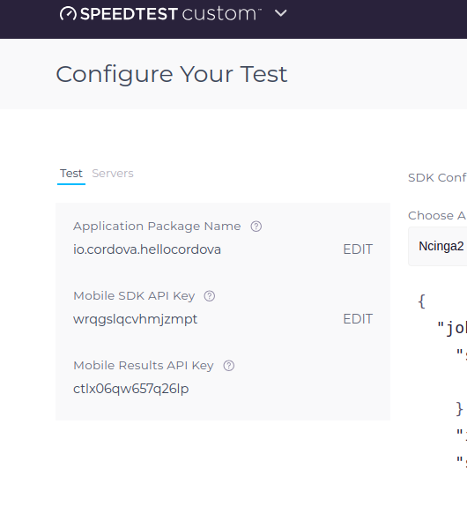
Parameters
const config = {
apiKey: "key",
config: "Ncinga2",
count:2
};

api key : Ookla API key
config: Keep as default configuration
count: Test execution cycle

Add Package name to Ookla Portal:
Update your current package name on Ookla configuration
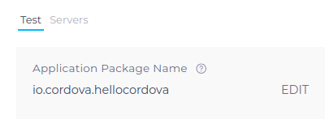

Execute Native Method:
window.cordova.exec(function (result) {
console.log(result);
}, function (error) {
console.log(error);
}, "SpeedTest", "extractJson", [JSON.stringify(config)]);

Result
ADB Log and save file
Result json files will be save on
/data/user/0/io.cordova.hellocordova/files/SpeedTest/
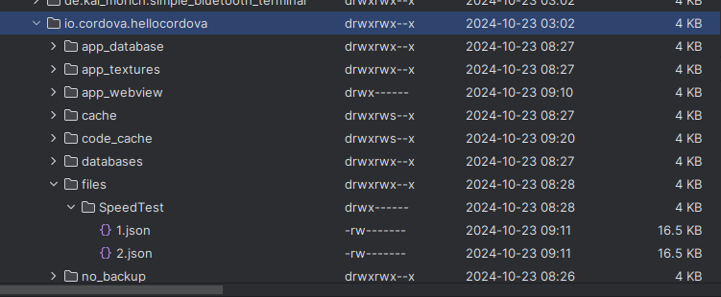
file name will be increment with loop count
ex : /data/user/0/io.cordova.hellocordova/files/SpeedTest/1.json
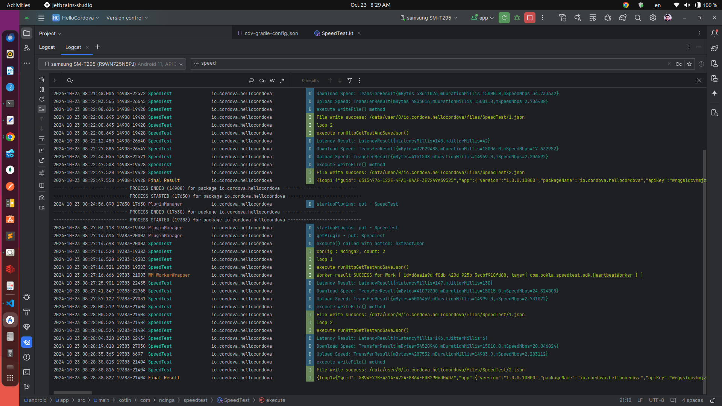
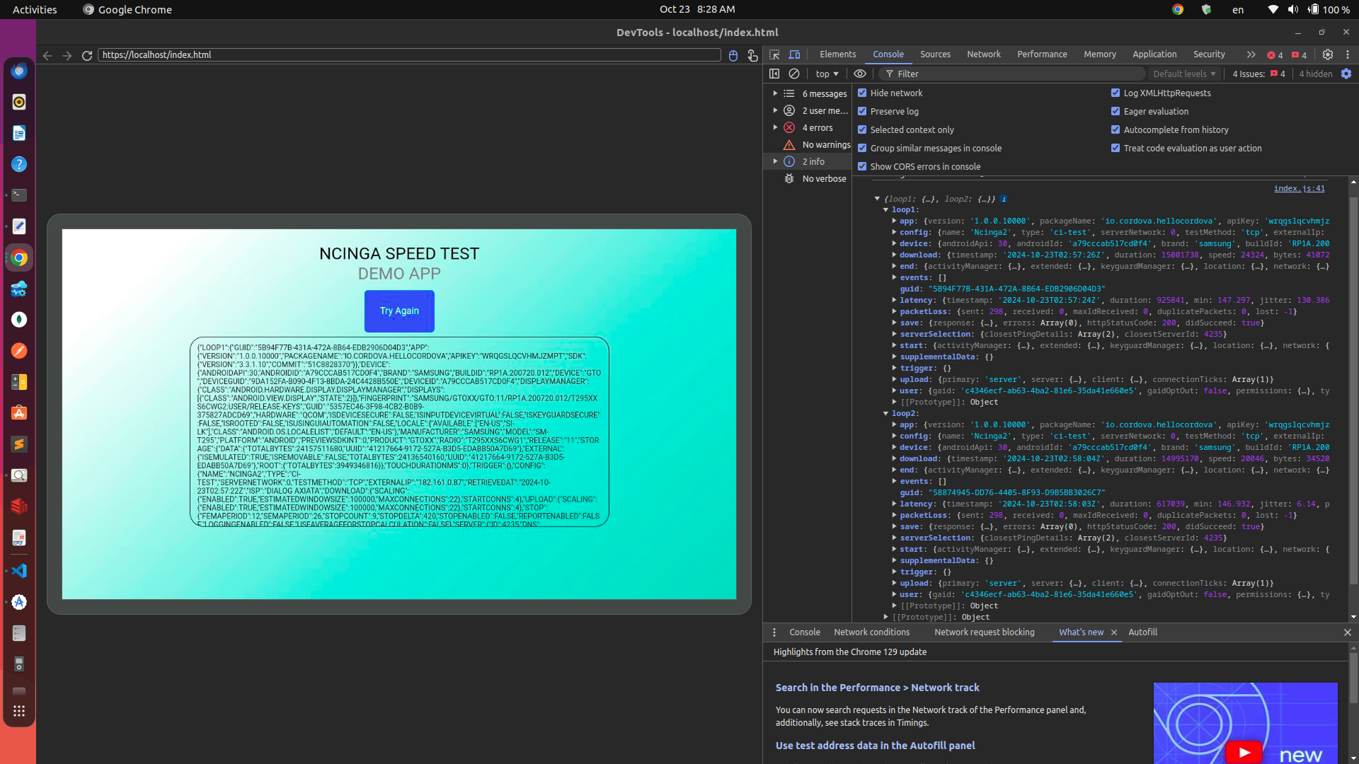
Console Log Result
When success result is returning through the success callback

